Phase 2: Innovation

* Consider incorporating data segmentation by time periods or countries for deeper insights.

Segmentation by Time Periods:

1. Daily, Weekly, or Monthly Analysis: Break down the data into daily, weekly, or monthly intervals. This can reveal trends in infection rates, recovery rates, and mortality rates over time.
2. Seasonal Trends: Consider how the pandemic has evolved over different seasons. For example, some areas may experience surges in cases during colder months, while others may see spikes during holidays or travel seasons.
3. Policy Changes: Analyze how different government interventions (lockdowns, mask mandates, vaccination drives) impact the trajectory of cases. This can help understand the effectiveness of various measures.
4. Vaccination Rollout: Segment the data based on when vaccines were introduced and distributed. This can shed light on the impact of vaccination campaigns on case numbers and severity.

Segmentation by Countries/Regions:

1. Comparative Analysis: Compare how different countries or regions have fared in terms of infection rates, mortality rates, healthcare capacity, and vaccination rates. This can provide insights into the effectiveness of various strategies.
2. Demographic Considerations: Consider how factors like population density, age distribution, healthcare infrastructure, and socio-economic conditions influence the spread and impact of the virus.
3. Policy Responses: Analyze how different countries' approaches to testing, contact tracing, quarantine measures, and vaccination strategies have affected the course of the pandemic.
4. Genomic Variants: Consider how the prevalence of different variants of the virus correlates with the trajectory of cases in different regions. This can help understand the impact of variants on transmission and severity.
5. Healthcare Capacity: Assess how healthcare systems in different countries have coped with the pandemic. Compare metrics like hospitalization rates, ICU capacity, and availability of medical resources.

Remember to account for potential biases in data reporting and collection methods when conducting this analysis. Additionally, consider cultural, social, and economic factors that may influence the spread and response to the virus in different regions.

By segmenting COVID-19 data in these ways, you can gain a more comprehensive understanding of the pandemic's dynamics and make more informed decisions regarding public health interventions, resource allocation, and risk assessment.

**Program:**

import pandas as pd

df = pd.read_csv("home/darkangel/Downloads/archive/covid-19-cases4.csv")

# Convert 'dateRep' column to datetime format

df['dateRep'] = pd.to_datetime(df['dateRep'])

# Set 'dateRep' as the index

df.set_index('dateRep', inplace=True)

# Segment data by time periods

monthly_data = df.resample('M').sum()

# Segment data by countries for deeper insights

countries = df['countriesAndTerritories'].unique()

for country in countries:

country_data = df[df['countriesAndTerritories'] == country]

# Perform analysis on country_data

# Example: Calculate total cases, deaths, etc. for each country

# Optional: Save or display results

# country_data.to_csv(f'{country}_covid_data.csv')

# Example analysis for each country

# For instance, calculating total cases and deaths

for country in countries:

country_data = df[df['countriesAndTerritories'] == country]

total_cases = country_data['cases'].sum()

total_deaths = country_data['deaths'].sum()

print(f'Country: {country}, Total Cases: {total_cases}, Total Deaths: {total_deaths}')

# Optionally, you can save the segmented data

# monthly_data.to_csv('monthly_covid_data.csv')

**output:**

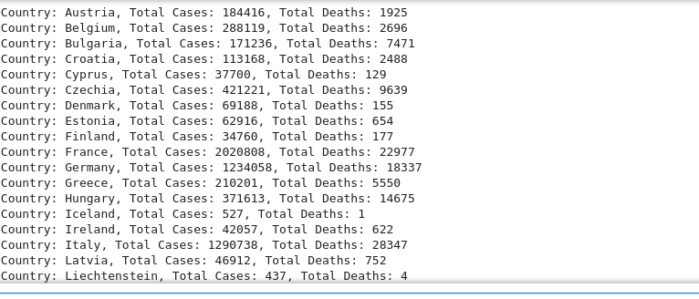

**TEAM MEMBERS:**

* Mohammed Salman.H
* Syed Waseemuddin
* Syed Hussain.SA
* Noor Ibrahim.G